

**INTI INTERNATIONAL COLLEGE SUBANG JAYA**

**CENTRE FOR AMERICAN EDUCATION (CAE)**

**INDIVIDUAL ASSIGNMENT 2 (15%)**

|  |  |  |  |  |
| --- | --- | --- | --- | --- |
| Programme Name | **AMERICAN UNIVERSITY PROGRAM (AUP)** | | | |
| Module Name | **C-LANGUAGE & UNIX OPERATING SYSTEM** | | Module Code | **CSC202A** |
| Session/Semester | **Jan 2020** |
| Module Leader Name | **K SHIVA** | | Assessment Type / Reference No. | **ASSIGN 2 / Jan 2020** |
| Students Name |  | | Matric No |  |
| Student’s declaration | I hereby certify that this assignment is my own work and where materials have been used from other resources, they have been properly acknowledged. Plagiarism is the use of someone else's ideas or work (including published work from the Internet) without appropriate acknowledgment or credit. Overall plagiarism should not exceed more than **20%**. This is an academic misconduct, which will result in the award of a zero mark. I also understand I will face the possibility of failing the module if the content of this assignment are plagiarized.  Signed: ________________________ Date: _________________ | | | |
| Learning Outcomes (s) / | |  | | --- | | * **LOC 1**: Build computer program using basic logic and operation principles. | | * **LOC 2**: Contrast computer program solution based on structured programming concept. | | * **LOC 3:** Demonstrate information management and lifelong learning skills in developing new computer program. | | | | |
| Release Date | **10.03.2020** | Due Date | **31.03.2020, 4PM-6PM**  **During Class** | **Marks obtained** |
| Date Received |  | Assessed by |  |

### Deliverables & Assessment Criteria:

**You are required to perform the following tasks and need to upload in safeassign link provided.**You are required to produce a report for the CSC202A as follows:

* **Softcopy (**required to upload the following tasks in **Safeassign** provided**)**

**Task 1 [50%]:**

Develop a complete **interactive menu driven program** code in C for the given scenario below, to receive and display all the required data by using appropriate ***comments, variable usage, program logic, I/O statements, looping structure***, ***validation,*** ***more interactive and user friendly*** *with* ***all******the******possible output*** *screens*.

Write a **C application** which performs the following scenarios:

1. Display an ***interactive design*** of a computer’s store and welcome message screen when start running the program. [**5%]**
2. Prompt the user to enter a Customer name, IC/Passport, etc., [**5%]**
3. List of available laptops as given below and prompt the user to select any **SIX (6)** choices:

***1-Acer, 2-HP, 3-Dell, 4-Lenovo, 5-Toshiba, 6-Sony.*** [**5%]**

*Hint: you are required to include the price of the laptop, which is your own choice.*

1. Display error message if the user enters choices other than 1 to 6. [**5%]**
2. For menu 2, and 5, there will be **NO** discount given, but for menu 1, 3, and 6, there will be a **5%** discount given, where by for menu 4, there will be a **10%** discount given.
3. Prompt the user to enter laptop’s selection (laptop price must be fixed) and quantity of laptop purchased only if the user enters the valid choices. [**5%]**
4. Calculate the Overall price, discount, GST (8%), and final Total and display the laptop’s purchase receipt along with customer details. [receipt must be ***interactive*** and which contains ***all the details***]. **[10%]**
5. Required to provide all the necessary **validation** wherever is required in task (ii) to task (vii). – [**15**%]

**Task 2 [20%]:**

Write a C program to apply String concept for the following scenario.

As we know, **there** is no current **way to see** who has actually viewed **your Facebook profile**, you can **see** who has recently been in some sort of contact with you through the **InitialChatFriendsList**, and **see** who has viewed **your** comments or posts in a Group or Message.

Hence, you are required to collect (only from facebook page) right click on your timeline and hit “View **page** Source”. Now, you'll be redirected to a new **page** with lots codes. Next to that word, you'll see a list of numbers, these are the profile ID's of people who **visit** your timeline. Just go to “Log In or Sign Up” and paste the ID number beside it with a “\” .

Upon collections of those ID’s, put into a string array and sort it out using string functions. Which ID was/were viewed most in your Facebook or profile page.

**Task 3 [5%]:**

Discuss at least **FIVE (5)** features of Unix Operating system.

**Task 4 [15%]:**

Write minimum **FIFTEEN (15)** simple **UNIX** commands which are quite often used for normal operation with required explanation including syntax if any.

**Task 5 [10%]**

Write an anagram program in C to check whether two given strings are an anagram or not.

**Hint:** An anagram is a word or phrase formed by rearranging the letters of a different word or phrase, typically using all the original letters exactly once.

**Expected Output:**

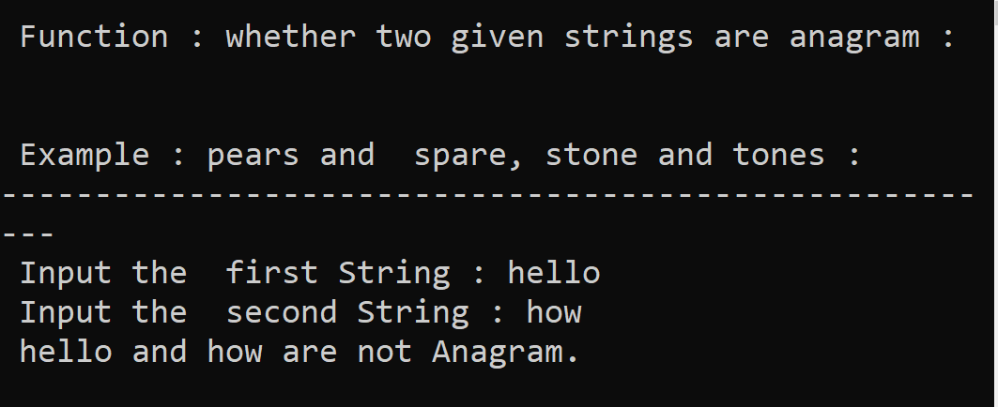

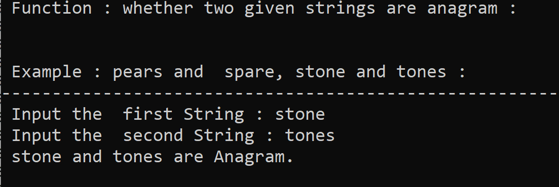

***Rubrics:***

|  |  |  |  |  |
| --- | --- | --- | --- | --- |
| **(Outstanding)** | **(Excellent)** | **(Good)** | **(Fair)** | **(Poor)** |
| Design of logic, testing, verification and validation, Standards (interactive, user-friendliness), **Any additional creative thinking** (80-100) | Program is logically well designed (71-79) | Program has slight logic errors that do no significantly affect the results (61-70) | Program has significant logic errors (51-60) | Program is incorrect (0-50) |
|  |  |  |  |  |
| **TOTAL** |  | | | |

**Instructions to Students:**

* Submit your work before or on published deadline, No late submission will be accepted, Use any referencing style.
* Plagiarism is an academic dishonesty. Submit your work in original. F grade will be awarded for a plagiarized/copied work.
* **Demonstration** of the C Codeand **viva-voce.** If you, failed to present, your assignment will be considered as*Null and Void***.**